**CST-256 Design Report Template**

|  |  |  |
| --- | --- | --- |
| **Topic:** | *Milestone 4: Affinity Group Modules* | |
| **Date:** | *May 9, 2021* | |
| **Revision:** | *4.0* | |
| **Team:** | 1. *Cameron Deao* | |
| 1. Mercedes Thigpen | |
| 1. Zachary Gardner | |
|  | |
| **Weekly Team Status Summary:** | |  |  |  |  | | --- | --- | --- | --- | | **User Story** | **Team**  **Member** | **Hours**  **Worked** | **Hours Remaining** | | *Preparing programming environment, design report. Database. design.* | *Zachary Gardner* | *10* |  | | *Github repository, initial project structure, class design, Database design.* | *Cameron Deao* | *14* |  | | *Design report, views, blade views.* | *Mercedes Thigpen* | *10* |  | |  |  |  |  | |  |  |  |  | |  |  |  |  | |  |  |  |  | |  |  |  |  | |  |  |  |  | |  |  |  |  | |  |  |  |  | |  |  |  |  | |  |  |  |  | | |
| **GIT URL:** | *https://github.com/cmdeao/CST-256-CLC/tree/Milestone4-Submission* | |
| **Screencast URL:** | *https://www.youtube.com/watch?v=Q5GK46Gv_Tw* | |
| **Peer Review:** | *Y* | We acknowledge that our team has reviewed this report and we agree to the approach we are all taking. |

**Design Documentation**

**Install Instructions:**

*Download and unzip project folder.*

*To view in Eclipse: File -> Import -> Existing Projects into Workspace -> Select Root Directory -> Finish*

**General Technical Approach:**

*As a team we’ll be creating a Professional Networking application. The project will be built within Eclipse and will leverage the open-source PHP framework Laravel alongside Composer.*

**Key Technical Design Decisions:**

*The project will be built utilizing the PHP, HTML, CSS, and JavaScript languages. Alongside the leveraged frameworks, the team will utilize GitHub as the project repository and Sourcetree for version control. Team members will create separate branches during milestone development and merge them into the ‘master’ branch through the use of pull requests.*

**ER Diagram:**

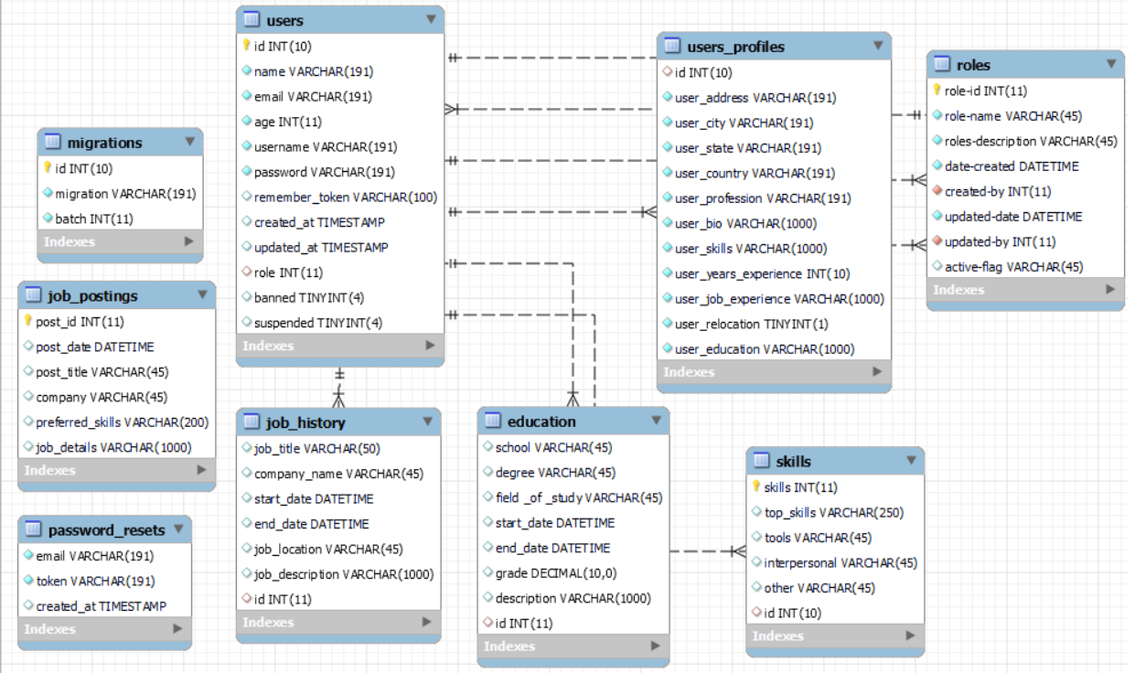

**DDL Scripts:**

*-- MySQL Script generated by MySQL Workbench*

*-- Sun May 2 19:36:41 2021*

*-- Model: New Model Version: 1.0*

*-- MySQL Workbench Forward Engineering*

*SET @OLD_UNIQUE_CHECKS=@@UNIQUE_CHECKS, UNIQUE_CHECKS=0;*

*SET @OLD_FOREIGN_KEY_CHECKS=@@FOREIGN_KEY_CHECKS, FOREIGN_KEY_CHECKS=0;*

*SET @OLD_SQL_MODE=@@SQL_MODE, SQL_MODE='ONLY_FULL_GROUP_BY,STRICT_TRANS_TABLES,NO_ZERO_IN_DATE,NO_ZERO_DATE,ERROR_FOR_DIVISION_BY_ZERO,NO_ENGINE_SUBSTITUTION';*

*-- -----------------------------------------------------*

*-- Schema mydb*

*-- -----------------------------------------------------*

*-- -----------------------------------------------------*

*-- Schema 256-clc*

*-- -----------------------------------------------------*

*-- -----------------------------------------------------*

*-- Schema 256-clc*

*-- -----------------------------------------------------*

*CREATE SCHEMA IF NOT EXISTS `256-clc` DEFAULT CHARACTER SET utf8 ;*

*USE `256-clc` ;*

*-- -----------------------------------------------------*

*-- Table `256-clc`.`roles`*

*-- -----------------------------------------------------*

*CREATE TABLE IF NOT EXISTS `256-clc`.`roles` (*

*`role-id` INT(11) NOT NULL,*

*`role-name` VARCHAR(45) NOT NULL,*

*`roles-description` VARCHAR(45) NOT NULL,*

*`date-created` DATETIME NOT NULL,*

*`created-by` INT(11) NOT NULL,*

*`updated-date` DATETIME NOT NULL,*

*`updated-by` INT(11) NOT NULL,*

*`active-flag` VARCHAR(45) NULL DEFAULT NULL,*

*PRIMARY KEY (`role-id`),*

*INDEX `updated-by_idx` (`updated-by` ASC) VISIBLE,*

*INDEX `created-by_idx` (`created-by` ASC) VISIBLE,*

*CONSTRAINT `created-by`*

*FOREIGN KEY (`created-by`)*

*REFERENCES `256-clc`.`users` (`id`)*

*ON DELETE NO ACTION*

*ON UPDATE NO ACTION,*

*CONSTRAINT `updated-by`*

*FOREIGN KEY (`updated-by`)*

*REFERENCES `256-clc`.`users` (`id`)*

*ON DELETE NO ACTION*

*ON UPDATE NO ACTION)*

*ENGINE = InnoDB*

*DEFAULT CHARACTER SET = utf8;*

*-- -----------------------------------------------------*

*-- Table `256-clc`.`users`*

*-- -----------------------------------------------------*

*CREATE TABLE IF NOT EXISTS `256-clc`.`users` (*

*`id` INT(10) NOT NULL AUTO_INCREMENT,*

*`name` VARCHAR(191) NOT NULL,*

*`email` VARCHAR(191) NOT NULL,*

*`age` INT(11) NOT NULL,*

*`username` VARCHAR(191) NOT NULL,*

*`password` VARCHAR(191) NOT NULL,*

*`remember_token` VARCHAR(100) NULL DEFAULT NULL,*

*`created_at` TIMESTAMP NULL DEFAULT NULL,*

*`updated_at` TIMESTAMP NULL DEFAULT NULL,*

*`role` INT(11) NULL DEFAULT NULL,*

*`banned` TINYINT(4) NULL DEFAULT '0',*

*`suspended` TINYINT(4) NULL DEFAULT '0',*

*PRIMARY KEY (`id`),*

*INDEX `role_idx` (`role` ASC) VISIBLE,*

*CONSTRAINT `role`*

*FOREIGN KEY (`role`)*

*REFERENCES `256-clc`.`roles` (`role-id`)*

*ON DELETE NO ACTION*

*ON UPDATE NO ACTION)*

*ENGINE = InnoDB*

*AUTO_INCREMENT = 10*

*DEFAULT CHARACTER SET = utf8mb4*

*COLLATE = utf8mb4_unicode_ci;*

*-- -----------------------------------------------------*

*-- Table `256-clc`.`education`*

*-- -----------------------------------------------------*

*CREATE TABLE IF NOT EXISTS `256-clc`.`education` (*

*`school` VARCHAR(45) NULL DEFAULT NULL,*

*`degree` VARCHAR(45) NULL DEFAULT NULL,*

*`field _of _study` VARCHAR(45) NULL DEFAULT NULL,*

*`start_date` DATETIME NULL DEFAULT NULL,*

*`end_date` DATETIME NULL DEFAULT NULL,*

*`grade` DECIMAL(10,0) NULL DEFAULT NULL,*

*`description` VARCHAR(1000) NULL DEFAULT NULL,*

*`id` INT(11) NULL DEFAULT NULL,*

*INDEX `education_idx` (`id` ASC) VISIBLE,*

*CONSTRAINT `education`*

*FOREIGN KEY (`id`)*

*REFERENCES `256-clc`.`users` (`id`)*

*ON DELETE NO ACTION*

*ON UPDATE NO ACTION)*

*ENGINE = InnoDB*

*DEFAULT CHARACTER SET = utf8;*

*-- -----------------------------------------------------*

*-- Table `256-clc`.`job_history`*

*-- -----------------------------------------------------*

*CREATE TABLE IF NOT EXISTS `256-clc`.`job_history` (*

*`job_title` VARCHAR(50) NULL DEFAULT NULL,*

*`company_name` VARCHAR(45) NULL DEFAULT NULL,*

*`start_date` DATETIME NULL DEFAULT NULL,*

*`end_date` DATETIME NULL DEFAULT NULL,*

*`job_location` VARCHAR(45) NULL DEFAULT NULL,*

*`job_description` VARCHAR(1000) NULL DEFAULT NULL,*

*`id` INT(11) NULL DEFAULT NULL,*

*INDEX `job_history_user_id_idx` (`id` ASC) VISIBLE,*

*CONSTRAINT `user_job_history`*

*FOREIGN KEY (`id`)*

*REFERENCES `256-clc`.`users` (`id`)*

*ON DELETE NO ACTION*

*ON UPDATE NO ACTION)*

*ENGINE = InnoDB*

*DEFAULT CHARACTER SET = utf8;*

*-- -----------------------------------------------------*

*-- Table `256-clc`.`job_postings`*

*-- -----------------------------------------------------*

*CREATE TABLE IF NOT EXISTS `256-clc`.`job_postings` (*

*`post_id` INT(11) NOT NULL,*

*`post_date` DATETIME NULL DEFAULT NULL,*

*`post_title` VARCHAR(45) NULL DEFAULT NULL,*

*`company` VARCHAR(45) NULL DEFAULT NULL,*

*`preferred_skills` VARCHAR(200) NULL DEFAULT NULL,*

*`job_details` VARCHAR(1000) NULL DEFAULT NULL,*

*PRIMARY KEY (`post_id`))*

*ENGINE = InnoDB*

*DEFAULT CHARACTER SET = utf8;*

*-- -----------------------------------------------------*

*-- Table `256-clc`.`migrations`*

*-- -----------------------------------------------------*

*CREATE TABLE IF NOT EXISTS `256-clc`.`migrations` (*

*`id` INT(10) UNSIGNED NOT NULL AUTO_INCREMENT,*

*`migration` VARCHAR(191) NOT NULL,*

*`batch` INT(11) NOT NULL,*

*PRIMARY KEY (`id`))*

*ENGINE = InnoDB*

*AUTO_INCREMENT = 4*

*DEFAULT CHARACTER SET = utf8mb4*

*COLLATE = utf8mb4_unicode_ci;*

*-- -----------------------------------------------------*

*-- Table `256-clc`.`password_resets`*

*-- -----------------------------------------------------*

*CREATE TABLE IF NOT EXISTS `256-clc`.`password_resets` (*

*`email` VARCHAR(191) NOT NULL,*

*`token` VARCHAR(191) NOT NULL,*

*`created_at` TIMESTAMP NULL DEFAULT NULL,*

*INDEX `password_resets_email_index` (`email` ASC) VISIBLE)*

*ENGINE = InnoDB*

*DEFAULT CHARACTER SET = utf8mb4*

*COLLATE = utf8mb4_unicode_ci;*

*-- -----------------------------------------------------*

*-- Table `256-clc`.`skills`*

*-- -----------------------------------------------------*

*CREATE TABLE IF NOT EXISTS `256-clc`.`skills` (*

*`skills` INT(11) NOT NULL,*

*`top_skills` VARCHAR(250) NULL DEFAULT NULL,*

*`tools` VARCHAR(45) NULL DEFAULT NULL,*

*`interpersonal` VARCHAR(45) NULL DEFAULT NULL,*

*`other` VARCHAR(45) NULL DEFAULT NULL,*

*`id` INT(10) NULL DEFAULT NULL,*

*PRIMARY KEY (`skills`),*

*INDEX `user_skills_id_idx` (`id` ASC) VISIBLE,*

*CONSTRAINT `user_skills_id`*

*FOREIGN KEY (`id`)*

*REFERENCES `256-clc`.`users` (`id`)*

*ON DELETE NO ACTION*

*ON UPDATE NO ACTION)*

*ENGINE = InnoDB*

*DEFAULT CHARACTER SET = utf8;*

*-- -----------------------------------------------------*

*-- Table `256-clc`.`users_profiles`*

*-- -----------------------------------------------------*

*CREATE TABLE IF NOT EXISTS `256-clc`.`users_profiles` (*

*`id` INT(10) NULL DEFAULT NULL,*

*`user_address` VARCHAR(191) CHARACTER SET 'utf8mb4' COLLATE 'utf8mb4_unicode_ci' NOT NULL,*

*`user_city` VARCHAR(191) CHARACTER SET 'utf8mb4' COLLATE 'utf8mb4_unicode_ci' NOT NULL,*

*`user_state` VARCHAR(191) CHARACTER SET 'utf8mb4' COLLATE 'utf8mb4_unicode_ci' NOT NULL,*

*`user_country` VARCHAR(191) CHARACTER SET 'utf8mb4' COLLATE 'utf8mb4_unicode_ci' NOT NULL,*

*`user_profession` VARCHAR(191) CHARACTER SET 'utf8mb4' COLLATE 'utf8mb4_unicode_ci' NOT NULL,*

*`user_bio` VARCHAR(1000) CHARACTER SET 'utf8mb4' COLLATE 'utf8mb4_unicode_ci' NOT NULL,*

*`user_skills` VARCHAR(1000) CHARACTER SET 'utf8mb4' COLLATE 'utf8mb4_unicode_ci' NOT NULL,*

*`user_years_experience` INT(10) NOT NULL,*

*`user_job_experience` VARCHAR(1000) NOT NULL,*

*`user_relocation` TINYINT(1) NOT NULL,*

*`user_education` VARCHAR(1000) NOT NULL,*

*INDEX `user-user-id` (`id` ASC) VISIBLE,*

*CONSTRAINT `user-user-id`*

*FOREIGN KEY (`id`)*

*REFERENCES `256-clc`.`users` (`id`)*

*ON DELETE NO ACTION*

*ON UPDATE NO ACTION)*

*ENGINE = InnoDB*

*DEFAULT CHARACTER SET = utf8;*

*SET SQL_MODE=@OLD_SQL_MODE;*

*SET FOREIGN_KEY_CHECKS=@OLD_FOREIGN_KEY_CHECKS;*

*SET UNIQUE_CHECKS=@OLD_UNIQUE_CHECKS;*

**Sitemap Diagram:**

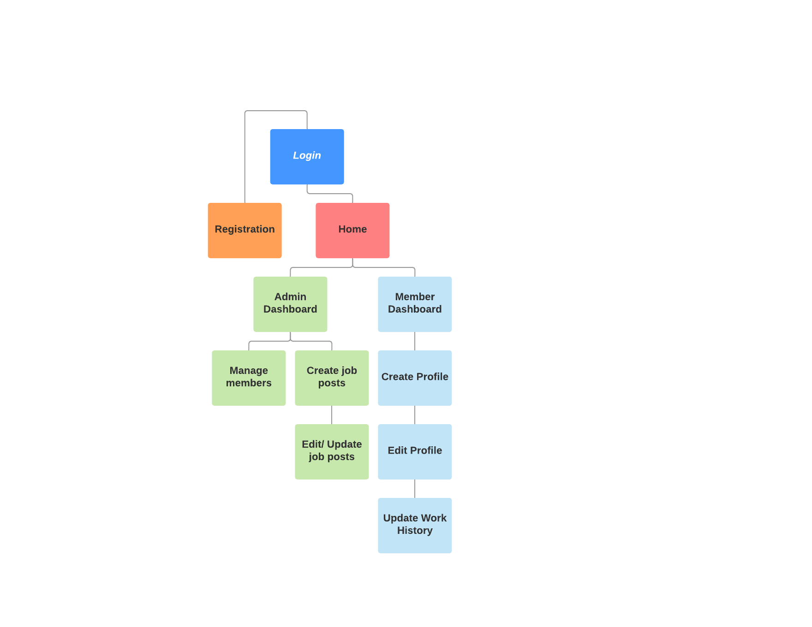

**Security Design:**

*Authentication and authorization will be achieved through the service classes and the Laravel framework. User submitted data will be stored within the appropriate tables of the database, and a form of encryption will be introduced to securely store passwords.*

**Third Party Interface Design:**

*Currently no Third Party Service Interface APIs are planned to be consumed. As planning and development progresses various options may be leveraged.*

**Flowcharts:**

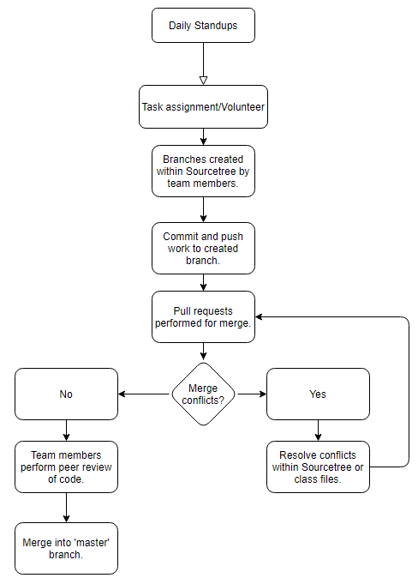

**User Interface Diagrams:**

*Login*

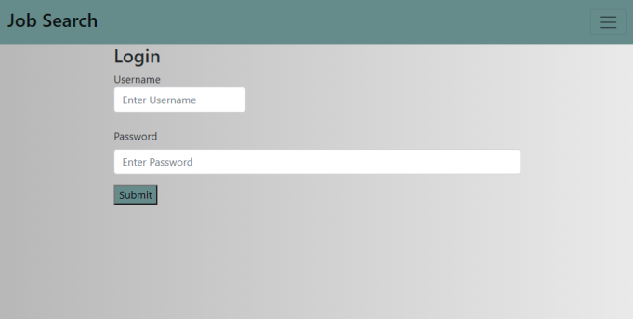

*Registration*

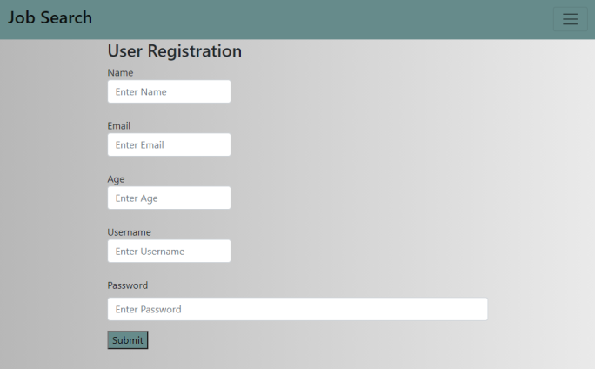

*Create Job Posting*

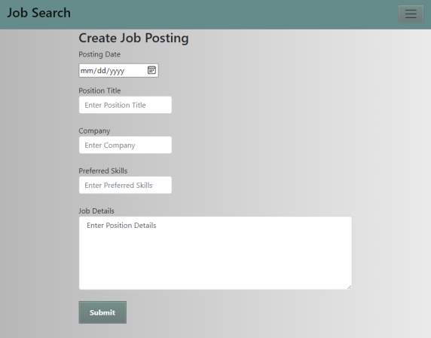

*Edit Job Posting*

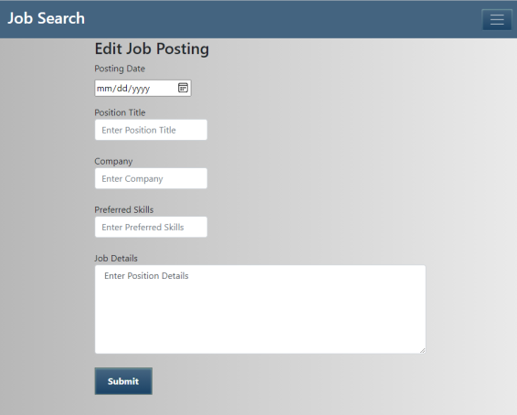

*Update Work History Page*

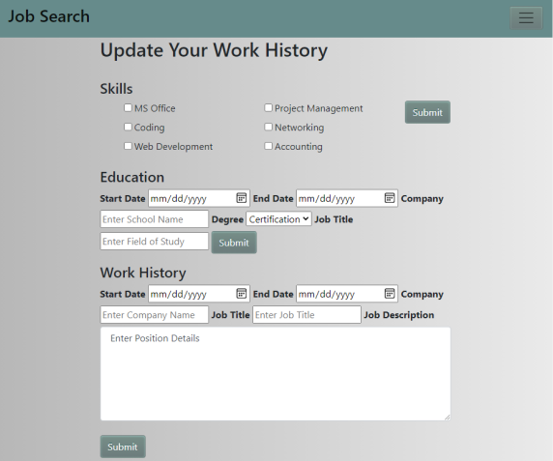

**Class Diagrams:**

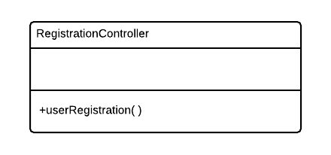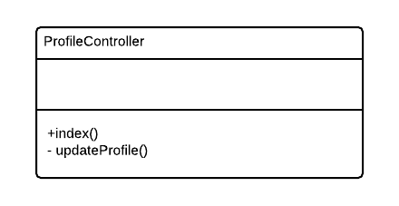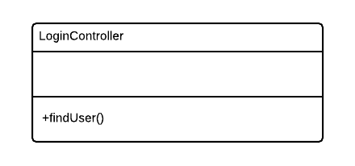

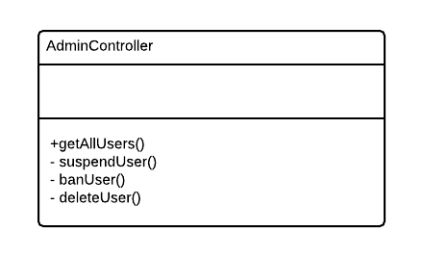

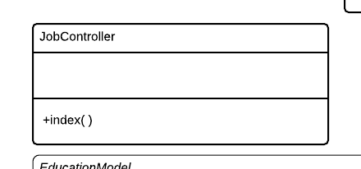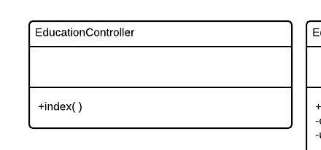

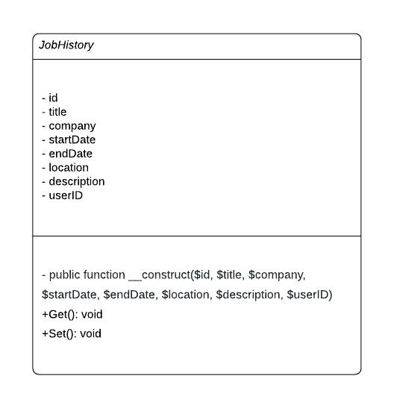

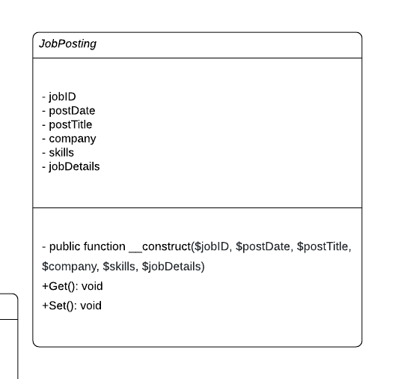

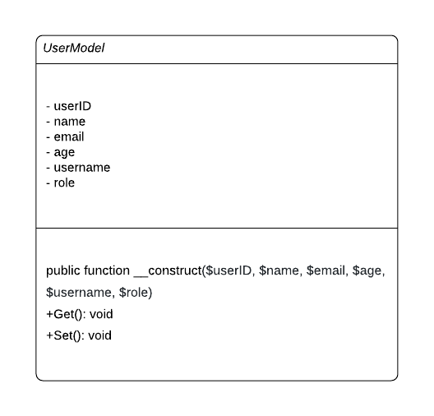

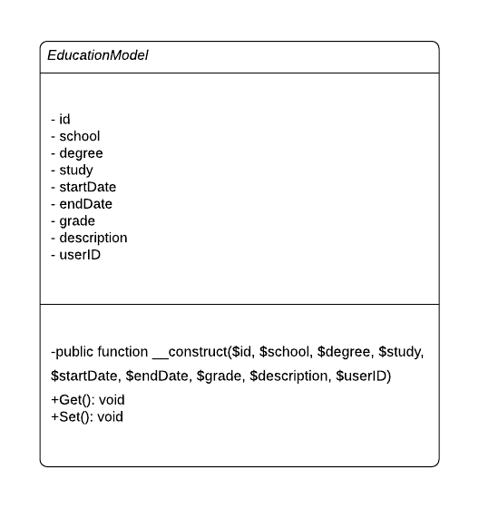

**Pseudo Code:**

*N/A – Currently no pseudo code exists within the application. This section will be updated as necessary as we move further into production and development.*

**Other Documentation:**

*N/A – Currently no additional drawings, storyboards, or schedules exist. This section will be updated as necessary as we move further into production and development.*